Milestone 2 Cybersecurity Project

Submitted By
Pooja Gopi Chetti Sai Charan

1. Introduction
This report is the milestone 1 progress of the project: SecureVault CLI. This milestone was to design and build the underlying security architecture of a secure and command-line-based key management and authentication system. Milestone 1 largely involves user registration and user entry, password management, cryptographic key generation, encrypted key storage in the private key and application of simple threat and modelling that is in tandem with secure systems design.

2. Project Overview
SecureVault CLI is a security-oriented system intended to achieve key-pair cryptography based on ECDSA (secp256k1), secure storage of private keys based on encryption mechanisms, user authentication based on stateless authentication using JWT, secure storage of user credentials based on hash-based passwords (bcrypt), and prevent brute-force intrusion by an implemented lockout mechanism of the login process. The system adheres to safe coding rules and employs organised threat modelling to deal with typical security threats on the architectural level.

3. Work Completed in Milestone 1

3.1 System Architecture Design
FastAPI was used in the system architecture as the backend. Modular structure was used to enhance maintainability and separation of concerns. The API is compiled to main.py, database models are defined in models.py, connection to the database is controlled in database.py and cryptography tools are found in security.py. A .env file was used to configure secure environment variables in order to make sure that sensitive configuration values are not hardcoded in the source code.

3.2 User Registration System
A user interface was done in the form of an option-based registration and a login interface. Password strength validation was imposed to guarantee that all user passwords are complex passwords that comply with the requirements of complexity such as minimum length, upper and lowercase letters, numbers, and special characters in a password. Bcrypt is used to hash passwords securely, and then the result is stored in a SQLite database. Consequently, plaintext passwords are never saved, and strong password enforcement minimises the chances of credit theft.

3.3 User Login System
The authentication process has the JWT token generation to support stateless authentication. The verification of passwords is done at the level of comparison of hash functions written on BCrypt. A mechanism of tracking failed attempts to log in was introduced in order to track failed attempts to log in, and accounts are blocked temporarily when several attempts to log in have failed. This will help to reduce brute-force attacks and increase the stability of the process of authentication.

3.4 Cryptographic Key Management
The ECDSA key generation on secp256k1 was used to secure cryptography key management. AES encryption is implemented in order to encrypt the private keys, and PBKDF2 is employed to derive the secure key. The database does not hold encrypted private keys in plaintext, but encrypts them. This is done to provide confidentiality of private keys and safeguard of life cycle against unauthorised access.

3.5 Threat Modelling (STRIDE)
To determine and examine the possible risks, spoofing, tampering, repudiation, information disclosure, denial of service, and elevation of privilege were identified and analysed as potential risks through a structured threat modelling. The authentication and encryption design included mitigation strategies to help curb these threats at the system level.

3.6 Secure Configuration
The system has environment variables where sensitive secrets and configuration parameters are stored. There are no hard-coded secret keys present in the application. Also, safe and properly maintained dependencies were chosen in order to reduce the vulnerability in the software stack.
4. Technologies Used
The technology used in this project of the Secure Key & Authentication System are:
i) Python
ii) FastAPI
iii) SQLite
iv) bcrypt
v) PyJWT
vi) cryptography
vii) AES
viii) PBKDF2
5. Security Measures Implemented
Area | Implementation
Password Storage | bcrypt hashing
Key Storage | AES-encrypted private keys
Authentication | JWT tokens
Brute Force Protection | Login attempt lockout
Secret Management | Environment variables
Threat Modeling | STRIDE methodology

6. Limitations of Milestone 1
Despite the appropriate implementation of the underlining security mechanisms, there are a number of shortcomings. The operating system is a CLI-only program that does not have a graphical front end interface. No refresh token is available to control long authentication periods. Role-Based Access Control (RBAC) is yet to be installed and there is limited logging and monitoring. There is no audit trail system, so it decreases the traceability of user actions. It has not been designed to include API-level rate limiting, and the fact that it uses SQLite limits its ability to scale to a production-level deployment.

7. Work to be Completed in Upcoming Milestones

7.1 Milestone 2 (Planned)
The second milestone will involve the provision of sophisticated security controls and architectural enhancements. These are the adoption of Role-Based Access Control (RBAC), limit rates of API, token refresh policy, audit log, better error management, structured logging and Docker containerization to enable deployment and scalability.

7.2 Milestone 3 (Future Enhancements)
Possible improvements in the future include the plan to migrate the system to PostgreSQL to have a more scalable one, introduce multi-user support of key vault, Hardware Security Module (HSM) capabilities, Two-Factor Authentication (2FA), develop safe backup and restore, move to cloud infrastructure, and introduce continuous security testing.

8. Conclusion
Milestone 1 manages to provide a safe base to the SecureVault CLI system. The authentication component, encrypted key storage and brute force protection systems are all operational and in tune with the principles of secure system design. The system has now provided confidentiality of the keys of the private keys, integrity of the authentication process, and protection against the usual attack vectors. Nevertheless, more improvements are needed to reach the production level. The next steps will be centred on scalability and advanced access control, monitoring features, and infrastructure hardening to enhance the general security position of the application.
Project Link
https://github.com/poojags77/SecureVault.git
Screenshorts
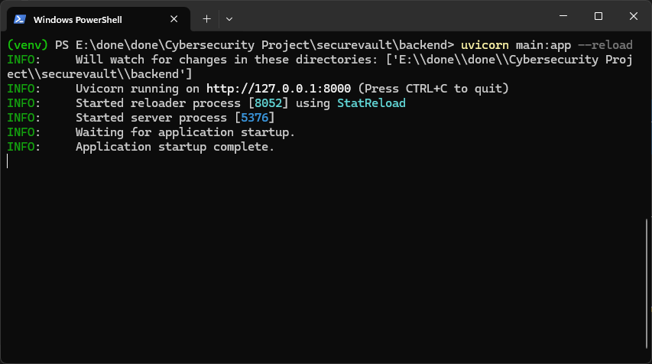
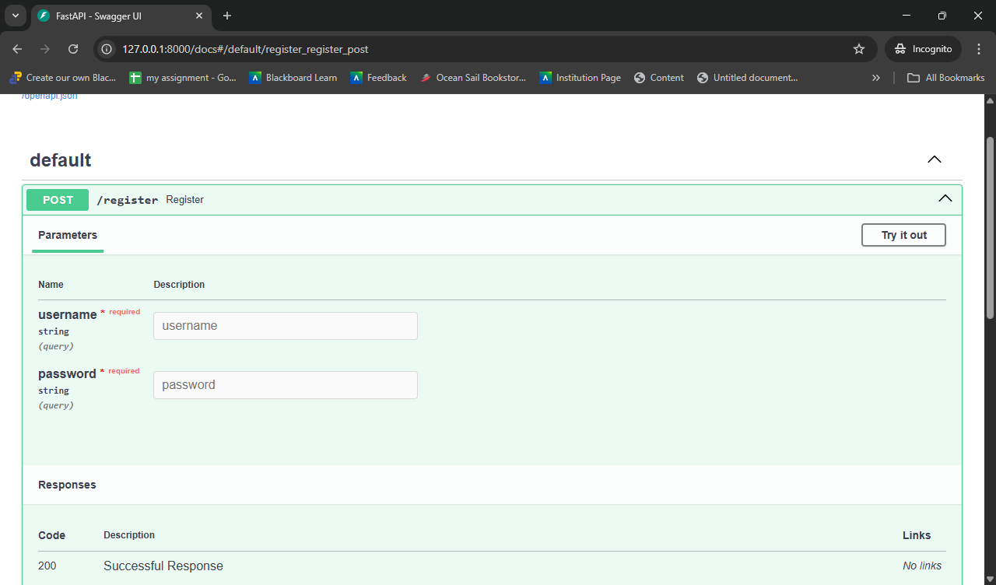

CLI
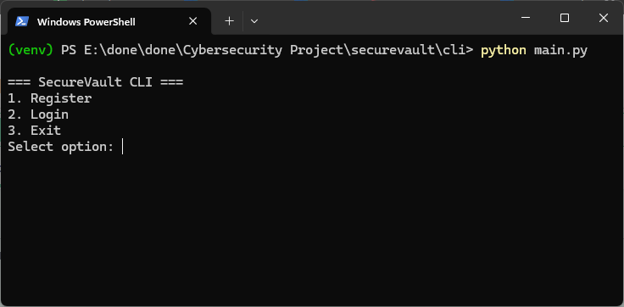
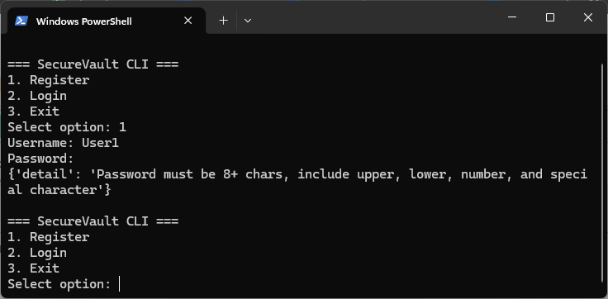
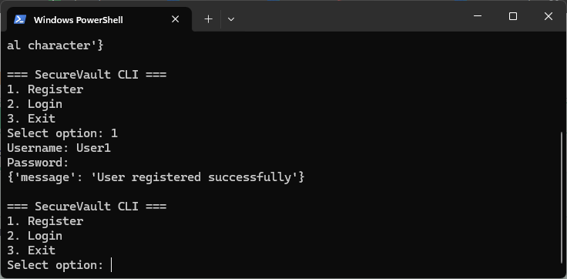
Log in:-
Username User1
Password:- Test1234@
